Human computer interaction design

**Phase #2 – Needs and requirements for SUrveypro, an online survey system**

Table of Contents

Project Description: Problem Space 2

Assumptions and claims 2

components of the conceptual model 3

Interface metaphors 3

Interaction types 3

Data Gathering 4

Quantitative Analysis/ Qualitative Analysis 5

Findings 15

Persona 16

Scenario 16

Use Case for SurveyPro 17

Key Requirements 20

Functional Requirements: 20

Data Requirements: 20

Envirnonmental Requirements: 21

User characterisitics: 21

Usability goals: 21

User experience goals: 22

Bibliography 23

# **Project Description: Problem Space**

SurveyPro aims to address a number of challenges that are prevalent in the world of online survey systems. These issues include limited choices on survey changes, a difficult user interface to create surveys, the possibility for error in data collection, poor availability of mobiles and no feedback loop between creators and respondents.

The limitations of the existing survey platforms are a major cause of these issues. Users find it difficult to create surveys that properly match their own demands because many platforms provide pre-designed templates that are rigid. A less than ideal user experience is also influenced by out-of-date user interfaces and design concepts.

By providing advanced design techniques, SurveyPro strives to solve these problems. The platform will place a high priority on user-friendliness and offer a full range of customization options. Users will have the ability to create surveys that are completely tailored to their goals, ensuring the accuracy and usefulness of the information collected. Additionally, a key feature will be mobile optimization, allowing users to easily access and complete surveys across multiple devices.

The proposed SurveyPro design concepts indicates a trend towards a more user-centric method of survey development. By giving users more customization options, real-time feedback mechanisms, and improved mobile accessibility, it expands the current paradigm. Users can take control of their survey experiences and get higher-quality data with this method.

# **Assumptions and claims**

Assumptions:

* Users desire a more user-friendly and adaptable survey creation process, and mobile compatibility is crucial for extending the reach of surveys.
* It also implies that survey creators place a high focus on collecting correct data and that quick feedback is helpful in enhancing survey quality.

Claims:

* A revolutionary solution that focuses on the flaws in current survey systems is offered.
* SurveyPro claims it can considerably improve the survey creation and data collection process by providing a platform that stresses user-centricity, comprehensive flexibility, and mobile friendliness.

# **components of the conceptual model**

The conceptual model underlying our website is likely to consist of the following components:

* Users of SurveyPro can choose from a variety of question types, personalize survey themes, configure logic and branching choices, and arrange questions using drag-and-drop capability. A database of suggested survey questions will be also part of this component.
* Surveys are made to be fully responsive, giving a consistent user experience on PCs, tablets, and mobile devices.
* A thorough analytics dashboard with interactive charts and graphs allows survey creators to monitor survey performance and examine the data that has been collected.
* During the survey design phase, the platform offers quick feedback and makes suggestions for modifications to increase survey quality and data accuracy.
* In order to make the creation and management of surveys easier over time, users have personal accounts that store their survey history and preferences.

# **Interface metaphors**

The survey creation interface in SurveyPro uses metaphors like the "survey canvas" to let users design their surveys graphically. The "survey dashboard" serves as the hub for managing and analyzing surveys.

# **Interaction types**

Drag-and-drop capabilities, editing for question customisation, and interactive data visualization tools for in-depth analysis are examples of interaction types. In order to improve users' overall experience, the platform also incorporates real-time notifications and user-friendly tooltips to direct users through the survey production process.

# **Data Gathering**

**Goals of Data Gathering:** The main objective of our data collection is to fully comprehend the needs and preferences of our target users, who are those interested in using online survey systems. We want to learn about their current procedures, identify the key functionalities and features that they view as crucial, and find out what they think about the shortcomings and difficulties of the current survey tools. With the use of this information, we will be able to customize SurveyPro to better suit their unique requirements and preferences.

**Identifying Participants:** Participants who represent a wide range of people interested in online survey technologies will be chosen. Since they are our main target consumers, this will also include professionals, researchers, educators, and students.

**Chosen Data Gathering Technique(s) and Scripts/Questions:** To get information from our target users, we plan to use both online surveys and in-person focus groups. While the in-person focus groups will provide us the ability to get qualitative data and learn more about the needs and preferences of our target users, the online surveys will be used to gather quantitative data.

The online survey will include both closed-ended and open-ended questions about topics including current experiences with online survey platforms, opinions on the significance of key features and functions, and suggestions on the potential downsides and problems with existing online survey websites.

**Pilot Studies:** We will run pilot studies with a limited number of participants before the main data gathering procedure to test our scripts, questions, and frameworks. This will enable us to improve our data collection methods and make sure they successfully capture the data we need.

**Demographic Data and Targeting Data:** We are going to gather demographic data from participants, such as gender, age range, educational attainment, and employment history, in addition to the main data collection. We can utilize this information to validate that our sample matches the demographics of our target users and to analyze the acquired data's demographics.

Additionally, we'll employ targeted data collection to connect with particular segments of our user base who share similar interests, such experts in particular industries or teachers with particular educational backgrounds.

Finally, by collecting comprehensive data, including both user requirements and demographic information, we intend to develop SurveyPro, an efficient and user-centric online survey system, to meet the various needs of our target users.

# **Quantitative Analysis/ Qualitative Analysis**

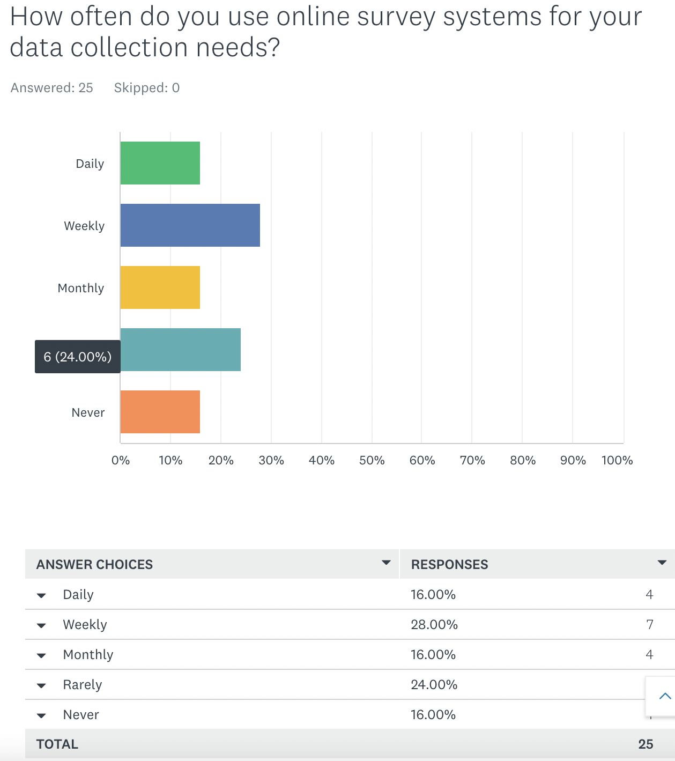

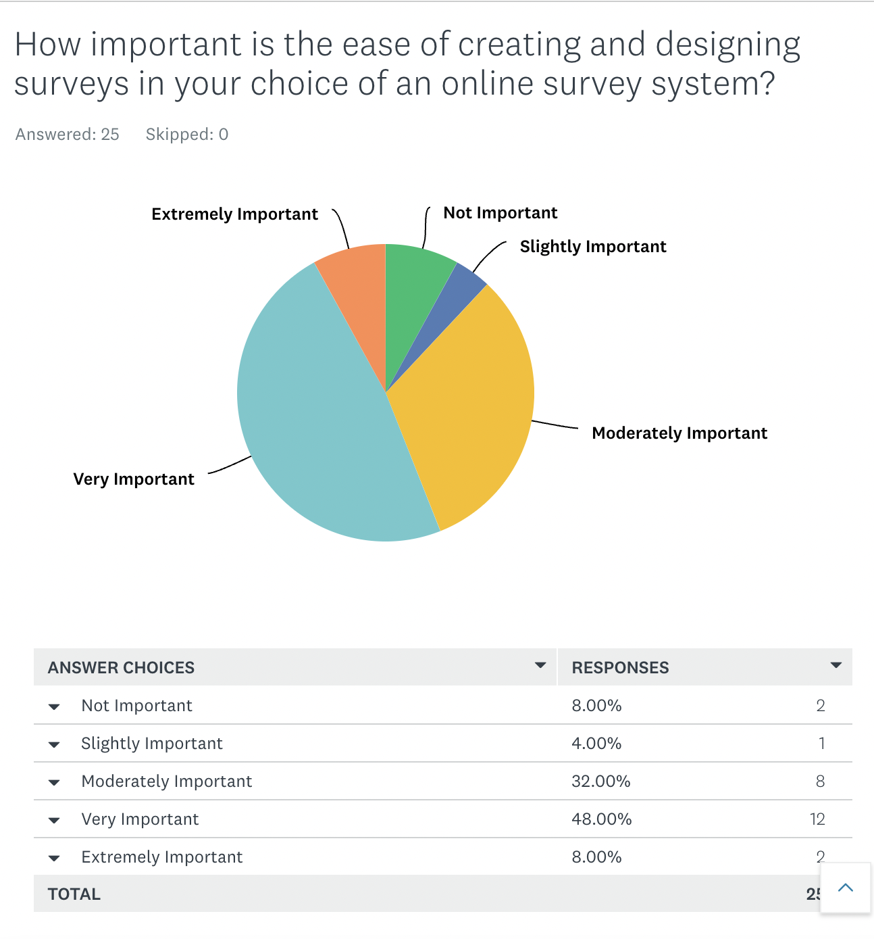

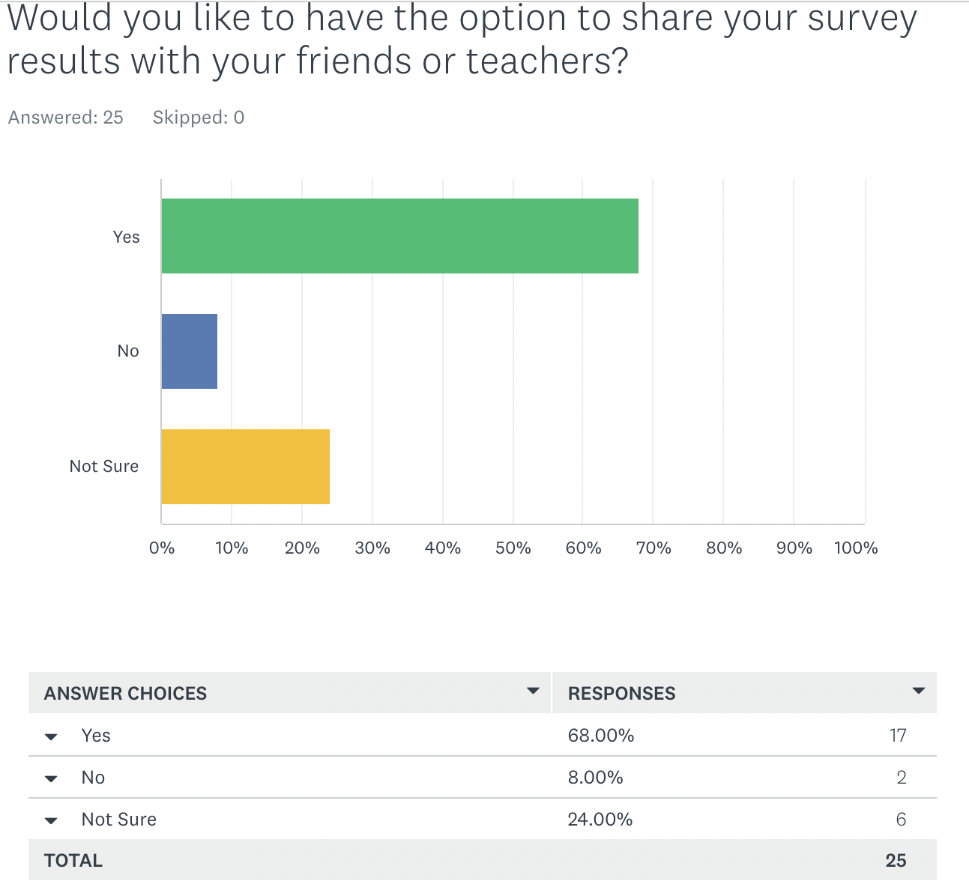

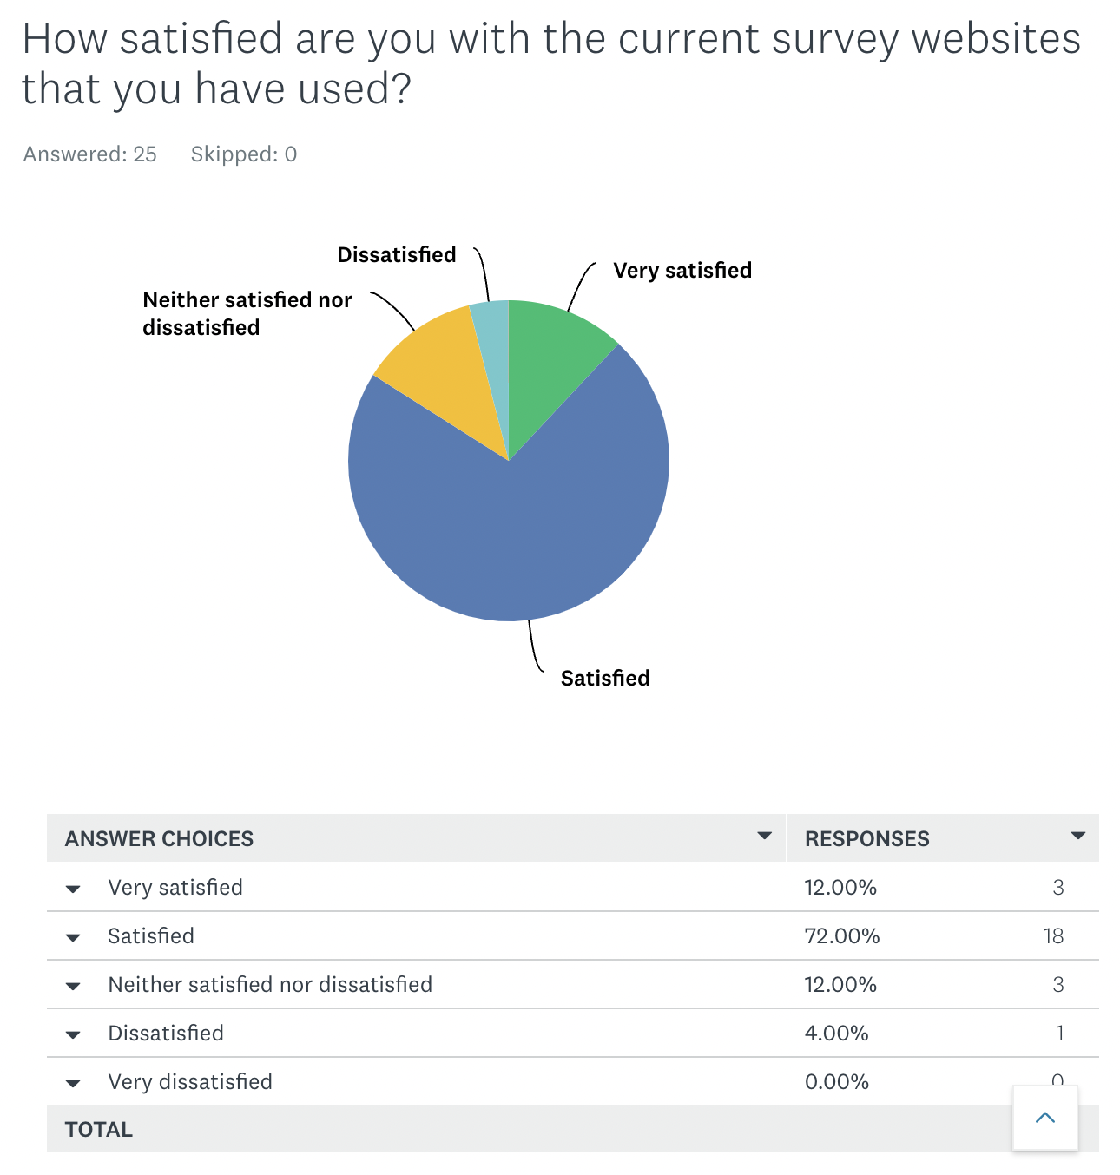

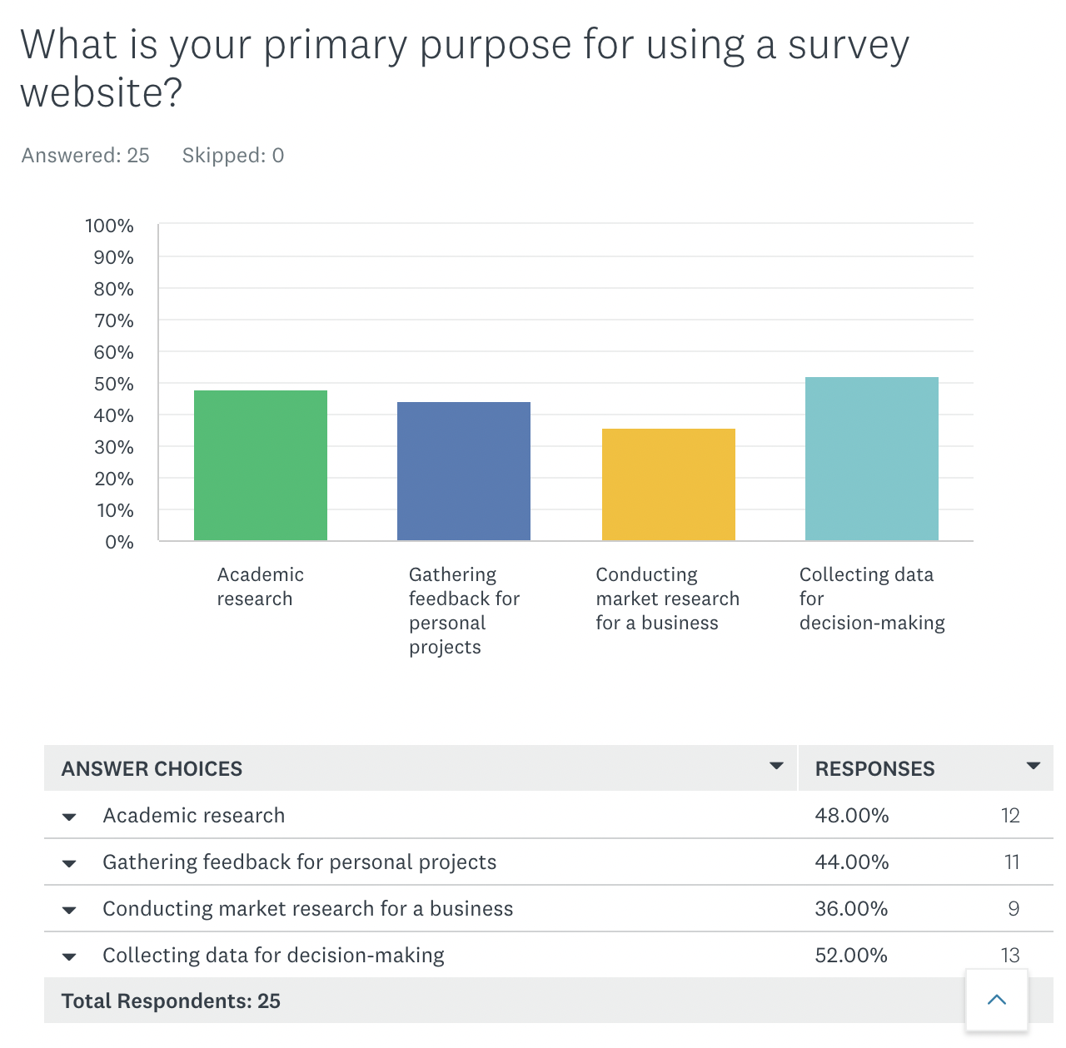

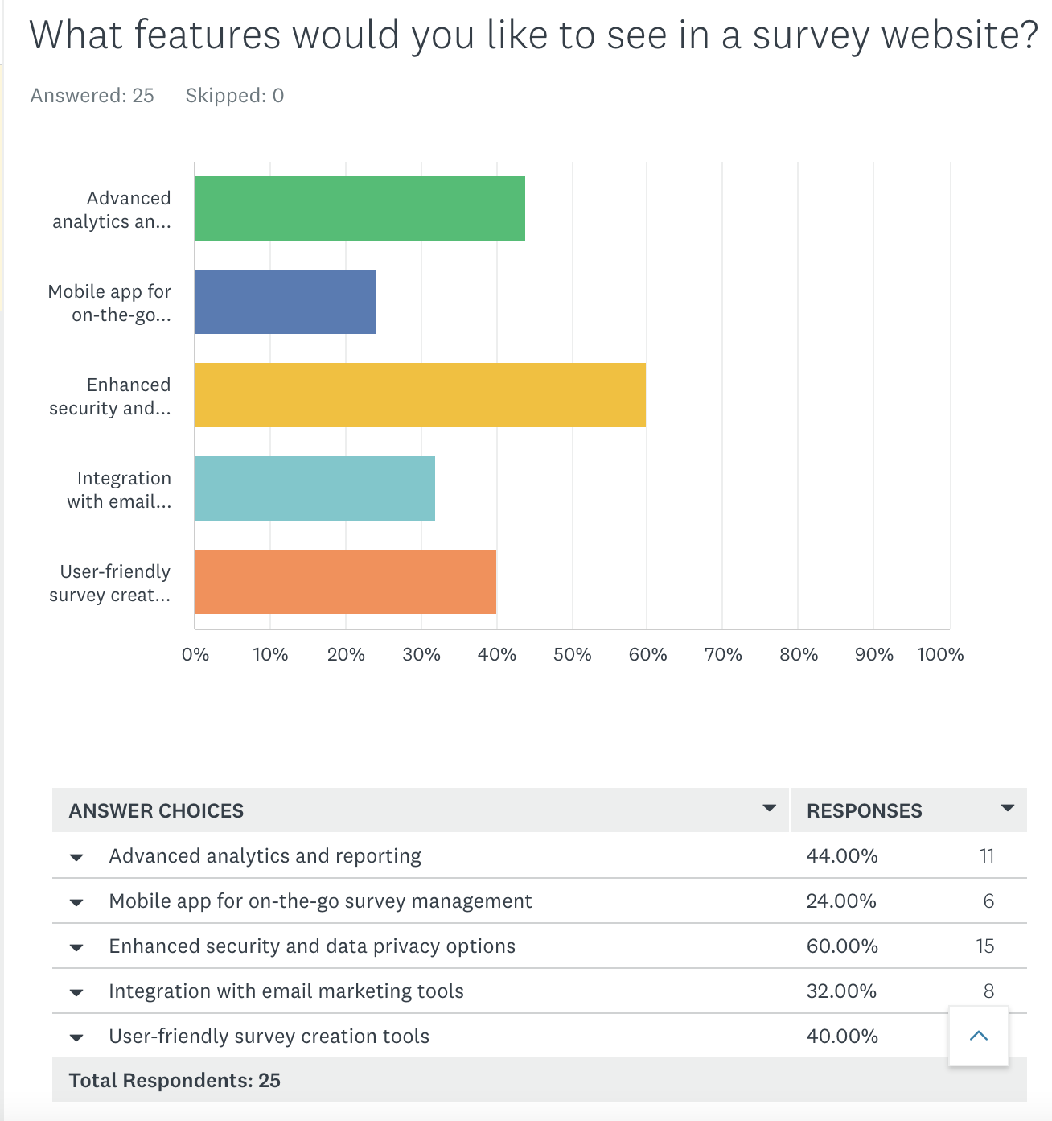

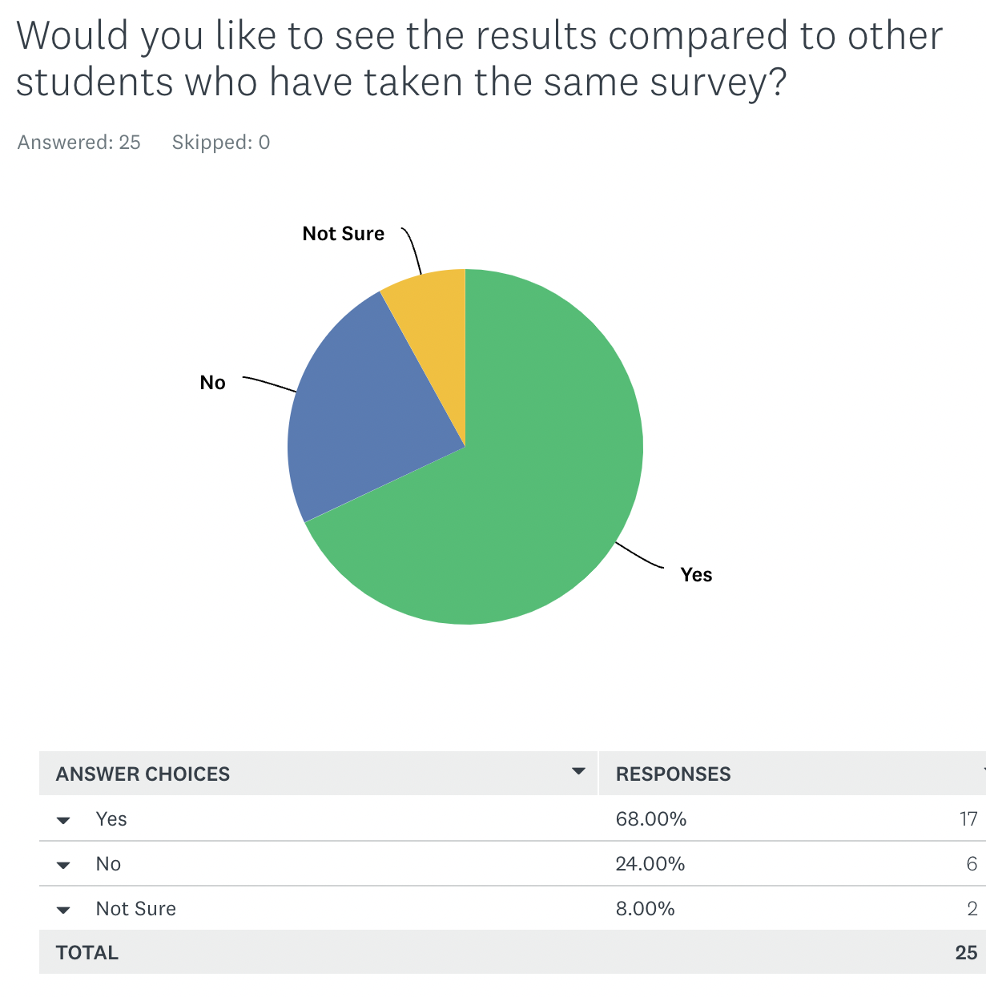

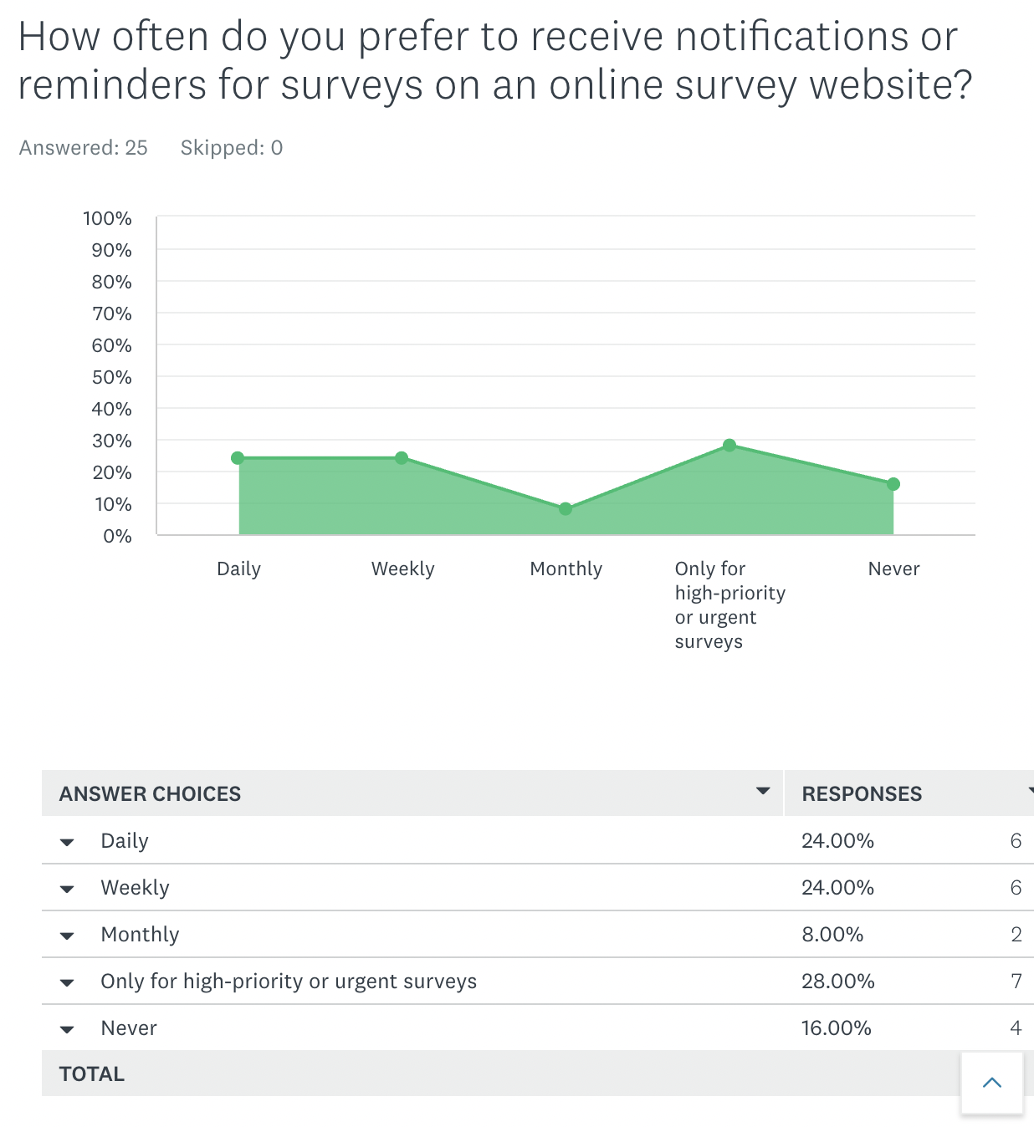





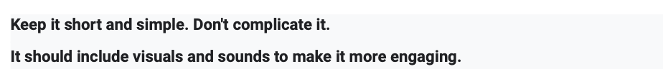

# **Findings**

About 25 people completed our surveys, and we collected data from them in order to learn more about user preferences and needs. We now have a stronger grasp of user demographics because of the analysis of user profiles and demographic survey responses, which enables us to assess and successfully meet their fundamental needs.

These results are crucial in assisting us in pinpointing our users' pain points and sources of dissatisfaction as well as prospective areas where SurveyPro's overall user experience could be improved. By utilizing this feedback, we can improve our platform to better meet the specific needs of our user base, resulting in a more gratifying and user-centric experience.

# **Persona**

# **Scenario**

Jake is a university student who is interested in conducting research for a biology class project. When he visits the SurveyPro website, he discovers an extensive collection of survey templates covering many subjects, including biology. He chooses the biological study template and starts building his survey by including project-related questions.

Jake discovers while he's creating his survey that he needs more data from his classmates before he finalizes the survey. He chooses to put his survey on hold and save it for later. Later on that day, he goes back to the internet to finish editing his survey, and editing process continues normally.

Jake initiates his survey and delivers it to his classmates for feedback after he is satisfied with it. He eagerly awaits the results as the responses start to come in. He selects the "View Results" button after the survey's data has been collected, and he is presented with insightful explanations and data visualizations right away.

Jake is pleased with his research's findings and is interested to see how they stack up against the work of his classmates. When he chooses the benchmarking option, he learns that, in terms of user engagement and response quality, the data from his project ranks in the top 10% of all surveys on SurveyPro about biology. His confidence soars as a result of this acknowledgment, which inspires him to keep improving academically.

Jake decides to share his accomplishments and inspire his peers to take part in next polls by posting a summary and analysis of his survey project on social media. In order to improve his

research abilities and broaden his understanding of biology, he also decides to investigate

additional survey templates on SurveyPro.

# **Use Case for SurveyPro**

|  |  |
| --- | --- |
| **Use Case Name:** | Conducting and Sharing A Survey |
| **Use Case Number:** | U01 |
| **Actors:** | * Student (User) * SurveyPro System |
| **Preconditions:** | * The student is successfully logged into their SurveyPro account using valid credentials. * The student has access to a survey template or has started creating a survey. * The student has good internet connection and a compatible device to use SurveyPro. |
| **Main Success Scenario:** | 1. The student logs into their SurveyPro account. 2. The student chooses a survey from the list of available surveys to create or continue modifying. 3. The student goes over the survey's guidelines and specifics, such as its goal, intended audience, and anticipated outcomes. 4. The student clicks "Start Survey" or "Continue Editing" to begin creating or revising the survey. 5. The survey creation/editing interface is displayed to the student, who can then add, modify, or delete survey choices and questions. 6. By selecting the "Pause" button, the student can stop creating and editing surveys if they need to take a break or come back to them later. The survey's development and modifications are preserved. 7. The student logs into their SurveyPro account and chooses the saved survey from the list of available surveys to continue working on it. 8. The student activates the survey by clicking the "Activate Survey" button once they have answered all the survey questions and are happy with the survey's layout. The survey is currently active and available for distribution. 9. Through email, social media, or other modes of communication, the student distributes the survey link to their classmates or other desired audience. 10. The student can access real-time survey results and data visualizations by selecting the "View Results" button as replies start to come in. 11. The student decides to share the survey insights with others after gathering responses and examining the survey results. They can send them through email or share the survey summary, important findings, and visualizations on social media after clicking the "Share Results" button. |
| **Postconditions:** | * The student used SurveyPro to successfully create, conduct and share their survey. * The student can access and use the survey's insights and results at any moment in the future. * The survey that the student created is stored in their SurveyPro account for later use or modification. |
| **Alternative Paths and Extensions:** | * After initiating the survey, the student may modify the survey's questions and settings by clicking the "Edit Survey" button. * if the student wants to compare the performance of their survey to that of other surveys on SurveyPro, the "Benchmarking" section of the platform provides access to benchmarking data and insights for students. * If the student receives feedback or comments from respondents, they can examine and react to these comments in the survey results section. |

# **Key Requirements**

# **Functional Requirements:**

User Account Creation and Management: In order for users to store and access their survey projects, track replies, and modify their account settings, SurveyPro must provide user account creation and management.

Creation and Management of Surveys: The platform should offer users a simple user interface for adding, amending, and organizing questions, setting time constraints, and defining survey complexity.

Reporting and Analytics: SurveyPro must provide strong reporting and analytics features that allow users to monitor survey development, track response information, and gain understanding of survey success over time.

Mobile Compatibility: Users should be able to access and manage surveys on the go with SurveyPro's compatibility with mobile devices, ensuring flexibility and convenience.

# **Data Requirements:**

To protect the safety and integrity of user survey data, the platform must emphasize secure data storage.

Strong data backup and recovery processes are necessary to avoid data loss in the event of system disruptions or failures.

Data Privacy: SurveyPro is required to observe strict data privacy standards, protecting user data, and making sure that data privacy laws are followed.

# **Envirnonmental Requirements:**

Scalability: The platform must be scalable in order to handle an expanding user base and growing survey data.

Reliability: To guarantee customers can access the platform regularly and without delays, SurveyPro should offer excellent reliability and uptime.

Accessibility: To encourage inclusivity, the platform must be available to all users, including those with disabilities.

# **User characterisitics:**

User-Friendly Interface: SurveyPro should have an easy-to-use interface that makes creating and managing surveys simple.

Choices for Customization: By choosing themes, styles, and customization choices, users should be able to tailor their survey experiences.

Individualized Content: The platform should offer recommendations and tips for individualized content that are based on the survey preferences and interests of each user.

# **Usability goals:**

Simple Navigation: In order to make it easy for users to find and use features, SurveyPro's navigation must be prioritized as being simple and effective.

Rapid Response: To avoid user frustration brought on by delays, the platform should provide quick responses and load times.

Strong error prevention and recovery techniques are required by SurveyPro in order to reduce user annoyance in the event of mistakes or problems.

# **User experience goals:**

Interactive and Engaging: To encourage users to explore and engage with survey creation and data analysis functions, the platform should include interactive and engaging elements.

Personalization: Users should be able to customize their survey experiences with SurveyPro to suit their unique requirements and preferences.

Relevant material: The platform ought to provide recommendations and material that are pertinent to the goals and preferences of users' surveys.

In conclusion, SurveyPro's development will be based on these fundamental needs, ensuring its usability and functionality in the field of online survey systems. Our goal is to develop a platform that caters to the requirements and preferences of survey designers and analysts while providing a fun and engaging user experience.

# **Bibliography**

Figma. (n.d.). Figma. <https://www.figma.com/files/recents-and-sharing/recently-viewed?fuid=1290771096602899247>

(n.d.). Cacoo | Online diagramming tool for collaborative diagramming | Nulab. [https://cacoo.com/](https://cacoo.com/signin)

(n.d.). Google Forms: Sign-in. <https://forms.google.com/>

Preece, J., Sharp, H., & Rogers, Y. (2015). Interaction design: Beyond human-computer interaction. John Wiley & Sons.

(2022, July 27). Qualtrics. <https://www.qualtrics.com/>

(n.d.). Stack Overflow. <https://stackoverflow.com/>

(n.d.). SurveyMonkey. <https://www.surveymonkey.com/>

(n.d.). Typeform. <https://www.typeform.com/>

Prototypes, C. (n.d.). Storyboard creator | Comic strip maker | Storyboard maker. Storyboard That. [https://www.storyboardthat.com/storyboard-creator#](https://www.storyboardthat.com/storyboard-creator)